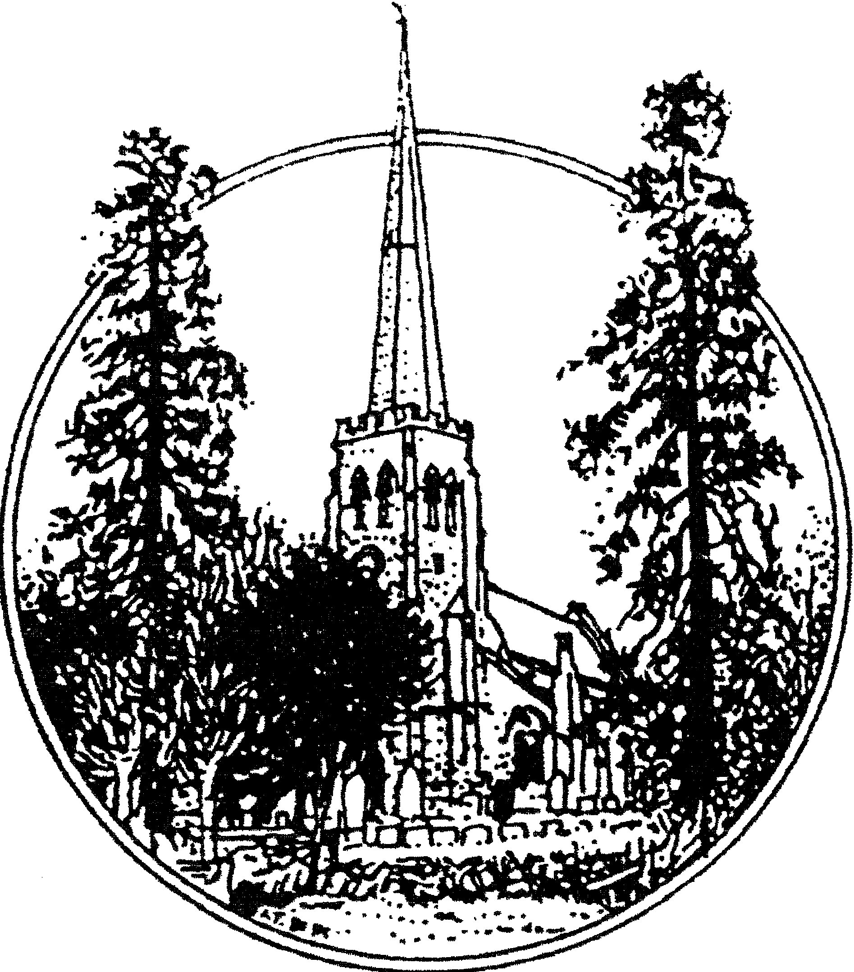


April 2026
Church of St Peter, Grandborough
The first church in Grandborough may have been a late Saxon chapel, held by Leofric, Earl of Mercia and his legendary wife, “Lady Godiva”. They gave Grandborough and the surrounding land to St Mary’s Benedictine Priory, Coventry.
Robert de Limesey, Bishop of Coventry and Lichfield gave considerable Priory Lands in Grandborough to his daughter Celestria and to her husband Noel, possibly as a dowry before 1100. The church almost certainly went with this and the gift was later ratified by Prior Lawrence to Noel and Celestria’s son Robert, who is said to be the founder of Grandborough Church. Anecdotal evidence suggests that the tomb, which originally stood where the organ is currently positioned, was “the founder’s tomb”, and is now located outside under the east window of the chancel.
The present church dates from about the middle and the tower from about the end of the 14th century. There was also a “Chapel of the Blessed Mary of Grandborough” in the medieval period, which may not have been a separate church, but is likely to have been a Lady Chapel within the present church.
Originally the church was dedicated to St Paul and this dedication was still in force up to 1730 but by 1743 it had been changed to St Peter’s.
We invite you to take a walk around the church, starting at the FONT. This was the gift of a previous vicar, the Rev H Bromfield, and his Churchwardens, G E Robinson and W L Sutton at a cost of £15 and was placed in the church on 25th April 1846. His memorial is on the south wall of the chancel. He also established the Sunday School in 1788.
Looking towards the TOWER, this was opened out in 1868 when the western gallery was removed. Presumably the BELLS had been rung from this level until then. They are hung for ringing and were last restored in 1810 at a cost of £100.7s.8d but are now in a very poor state of repair and are only chimed by means of Ellacombe apparatus in a cupboard in the tower.
The bells bear the following Inscriptions:
No. 1 Cantate domino canticum novum 1641 (O sing unto the Lord, a new song - Psalm 149)

No. 2 John Smith in Edgbaston made mee 1706.
No. 3 Henry Bagley made me 1641.
No. 4 Mr Christopher Tille, Minister, Mr Philemon Clarke and Mr John Goode, Churchwardens. Joseph Smith made mee 1706.
No. 5 By my voice the people may knowe to come to heare the word of God. Henry Bagly made me 1639.
Also in the tower can be seen a tablet listing some of the charities belonging to Grandborough.
From the tower arch, pause and admire the view of the long length of the nave to the altar. The church was re-seated in 1862-63, new material being used for nave and chancel and old miss-shaped pews used for the aisles. These had become so rotten, and worm-eaten that in 1976 they were removed and burnt and the flagstones laid. During this work the barrel roof of a vault was discovered in the north aisle and on removal of a loose brick, several coffins could be seen.
The accessible TOILET and SERVERY were added in 2010 at a cost of £73,458 and the wooden floor in the nave was replaced in 2013 at a cost of £7,036.
As we walk down the nave towards the altar we can observe on the north side of the CHANCEL what appears to be a small arched “window”. The HAGIOSCOPE or SQUINT is an opening through the wall of a church in an oblique position for the purpose of enabling persons in an aisle to see the elevation of the Host at the High Altar. This squint, which is not oblique, is ornamental only and was constructed in 1862.
We have now reached the ORGAN. The organ is believed to date from 1872. Parish records refer to a new organ at that time. It is typical of its period, arguably the best period for tonal design in England. The builder is not certain. The London instrumental retailer, J Cramer, has affixed his label to the console, but it is believed that he acted merely as a selling agent. Above the console door is an inscription in pencil on the framework “Wilson Shaw, Huddersfield, 8th June 1887.” This must have been done before the frame was assembled, since it would be impossible to do in situ. The outstanding feature of this organ is the brilliance of the upper work. The three-rank mixture on the great organ produces a climax to full organ remarkable in an organ of this size. The full specification will be found near the organ.
Three stops are not original, two having been transferred from the organ to the former Holy Trinity Church Rugby, and the pedal trombone having been added

in 1974. This rank appears to date from the late 19th Century, although the maker is unknown.
The organ was damaged by water ingress in the 1950’s and restored by J W Walker & Sons in 1958. Electric blowing was installed at the same time. Apart from the pedal trombone, the action is tracker and the wind pressure 3¼ inches. The trombone has electric action and 6 inches wind pressure. The pitch is about a quarter tone sharp of the standard ‘A’ 440 Hz.
A CHANTRY, at the east end of the north aisle, was walled off in 1813 and used as the first school in Grandborough for boys only, but later girls were admitted for reading and writing. John Lawrence, (after whom Lawrence Cottage was named) taught here from 1813 – 1840 when a new village school was built.
On the north wall of the chancel, beyond the vestry, is an AUMBRY or cupboard used to contain sacred vessels. It was discovered and, put to use in 1849 when plaster was stripped from the wall.
Behind the altar, the REREDOS of Caen stone was erected in 1849 and the floor laid with encaustic tiles. This was completely restored in 2025. We were very grateful to the National Lottery Heritage Fund and various trusts, along with parishioners for their donations. You can view the work in progress by going on to our web page http://www.stpetersgrandborough.co.uk.
On the south wall is a PISCINA, a water drain, placed near the altar used to receive water in which the celebrant washed his hands and the Communion vessels during Mass.
While standing in the chancel, a word about the WINDOWS. With the exception of the west window they were restored, repaired and re-glazed with diamond panes in 1849. The east window was the gift of G L Johnston and that on the north side which had been topped up was re-opened. That opposite the organ has been restored again (1989) in memory of a much loved local parishioner. The west window in the tower was re-glazed and the mullions restored in 1996; the work paid for by a generous local benefactor.
On leaving the chancel, note the PULPIT on the left and the READING DESK on the right which were first used on 12th July 1846. The old pulpit and sounding board had been removed and re-erected in Wolfhampcote Church.
As we retrace our steps down the nave, spare a glance upwards at the ROOF. In 1848, the nave and aisle ceilings were removed exposing old oak timbers. In 1863, they were taken down and the flat roof replaced with a pointed one resting on added clerestory walls. The aisle roofs were also restored to a “lean-to.” Since then, there have been numerous repairs to the nave roof, that in

1879 (after damage by lightening), costing about £120, that in 1982 costing £7,343, and the latest in 1996 costing £11,000. .We can also see from the nave, the arcading which is 14th Century work (note the hand-cut stones). The columns contain the usual characteristics of Decorated Gothic work – circular abacus, shallow moulding, octagonal pier and base. The arches are equilateral.
Before leaving by the south door, observe the presence of a second PISCINA in the south aisle which suggests that the south aisle was originally a Lady Chapel.
ARROW MARKINGS - Extremely good examples of holes and slits made by the sharpening of arrows on the wall are a reminder that churches were originally built for civil defence, as well as worship.
The Tower is over 65 feet and the spire rises another 61 feet and so the weather cock stands over 130 feet tall. The spire was re-pointed and a lightening conductor fixed in 1899. In 1913, the weathervane and top 8ft were taken down and rebuilt. In 1984-85, at a cost of £21,307.38, the upper 4ft were again rebuilt, several holes filled in and the weathercock re-gilded as the second stage of modern restoration work.
The CLOCK is believed to date from 1816, although there may have been an earlier one. The face was repainted in 1996. Automatic winding and pendulum regulation was added in 2007 at a cost of £6,915.
During 2025 we started fundraising in order to repair our clock and refurbishment will commence in the spring of 2026. We are very grateful for all the donations and grants we have received for this project.
CHURCHYARD - There are several gravestones to be noted. The oldest tombs, until recently smothered with ivy, date from the early 1600’s and hold the remains of residents of Sawbridge and Woolscott, the latter a wool comber who also resided in London.
In 2015 work was required on our stonework, belfry mullions and carving tracery heads. We were very fortunate to receive a generous grant from the Heritage Lottery Fund amounting to £131,000. However, the time taken to complete the carving was longer than first anticipated and it meant we were £9,000 short. An appeal was put out to our Parishioners who, thankfully responded, and we were able to reach the figure required to complete all the work to the stonework.
Web page: www.stpetersgrandborough.co.uk

